Math 4 Name_________________________

**Unit 3 Review** Date________

1. Use limit notation to describe the behavior of *j*(*x*) near its vertical and horizontal asymptotes. It would also be nice if you could draw a sketch of the function as well.



2. Add, subtract, multiply or divide the rational expressions below. Simplify your answer.



a. b.



c. d.

Determine the values of the properties below. Write “none” if one does not exist. The domain is for the original function.

3.  4. 

*Domain:_______________* *Domain:_______________*

*x-intercept(s):_______________* *x-intercept(s):_______________*

*y-intercept: _________ y-intercept: _________*

*horizontal asymptote(s):_______________* *horizontal asymptote(s):_______________*

*vertical asymptote(s): _______________ vertical asymptote(s): _______________*

*oblique asymptote:_______________ oblique asymptote:_______________*

*hole: _____________ hole: _____________*

5. The function *R(x)* models the percentage of RC Cola in a glass as a function of the number of ice cubes in the glass. Assuming you can put an infinite number of ice cubes in the glass (bad assumption) sketch a graph of *R(x)* and use the appropriate limit notation to describe your graph.

6. On the graph below, sketch a possible graph of the function *f(x)* with the following characteristics:

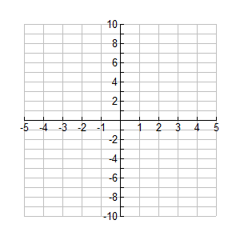

**\*\*\*Redo all the problems from any Unit 3 sheets/packets. Also, look over your last quiz!**